**TEST PLAN**

1. What is the System Under Test (SUT)? Provide a link (if available) and a brief description.

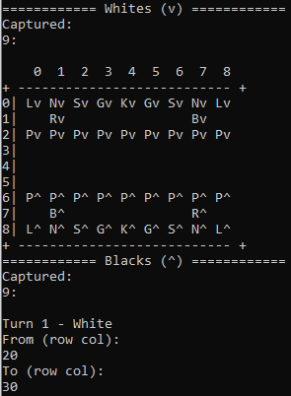<https://github.com/Urbistondo/Shogi>

This is a repository for a command line version of Shogi, the Japanese equivalent of chess. After cloning the repo and running the project’s Main.py, STDOUT will display within the cl in the form of a board of black and white pieces and their respective starting row and columns. Pieces can be moved by typing in corresponding numbers when asked. e.g.

2.

6 classes:

From GoldenGeneral.py – class GoldenGeneral(Piece)

From SilverGeneral.py – class SilverGeneral(Piece)

From Knight.py – class Knight(Piece)

From Pawn.py – class Pawn(Piece)

From ValidateMoveService.py – class ValidateMoveService

3.

Will be only automated unless 100% test coverage cannot be obtained

4.

Base choice coverage

Each choice coverage

All-uses coverage

5.

Unsure if this is classified as outside of Python’s environment (imported), but Python’s unittest will be used due to similarity with Java’s JUnit testing which I’m familiar with.